**BIL105-E**

**Intr to Sci&Eng Comp**

**CRN: 22596**

**I.Homework**

**Instructor:**

Yusuf YASLAN

**Student’s Name and Number:**

Tuğrul YATAĞAN

040100117

**Date: 14.03.2012**

1. Introduction

Project is about, writing a program that plays “Guess the number” game with the computer. The program starts with asking the user if she/he wants to guess the number that computer holds between 1-100 or if she/he wants to hold the number and let the computer guess. In each case the number holder is going to give the guesser a clue. The clue tells if the recently guessed number is greater than or less than the number being hold.

1. Development and Runtime environment

The project was developed on Linux **Ubuntu 11.10** distribution operation system. **GCC** (g++) compiler was used for compiling and **Geany** was used as integrated development environment program.

Program compiles and then run without input parameter. Program works on only ***main()*** function, there is no sub-function. Program includes ***iostream, cstdlib*** and***ctime*** standard C++libraries.

***srand(time(NULL))*** function is used for generating random variables between required integer range.

1. Variables

**UPPER_LIMIT** and **LOWER_LIMIT** are global variables which are used for limiting lowest and highest value. **step** is integer variable which is used for counting steps. **random_number** is integer variable which gets values from ***rand()*** function. **users_guess**, **comp_guess**, **low_limit** and **up_limit** are integer variables which are necessary for getting values from user, calculation and declaration values to the user. **users_clue** is string variables which is used getting characteristic clues from user. **more** is boolean variables which is used for run or terminate the while loop in the program.

1. Program Flowchart

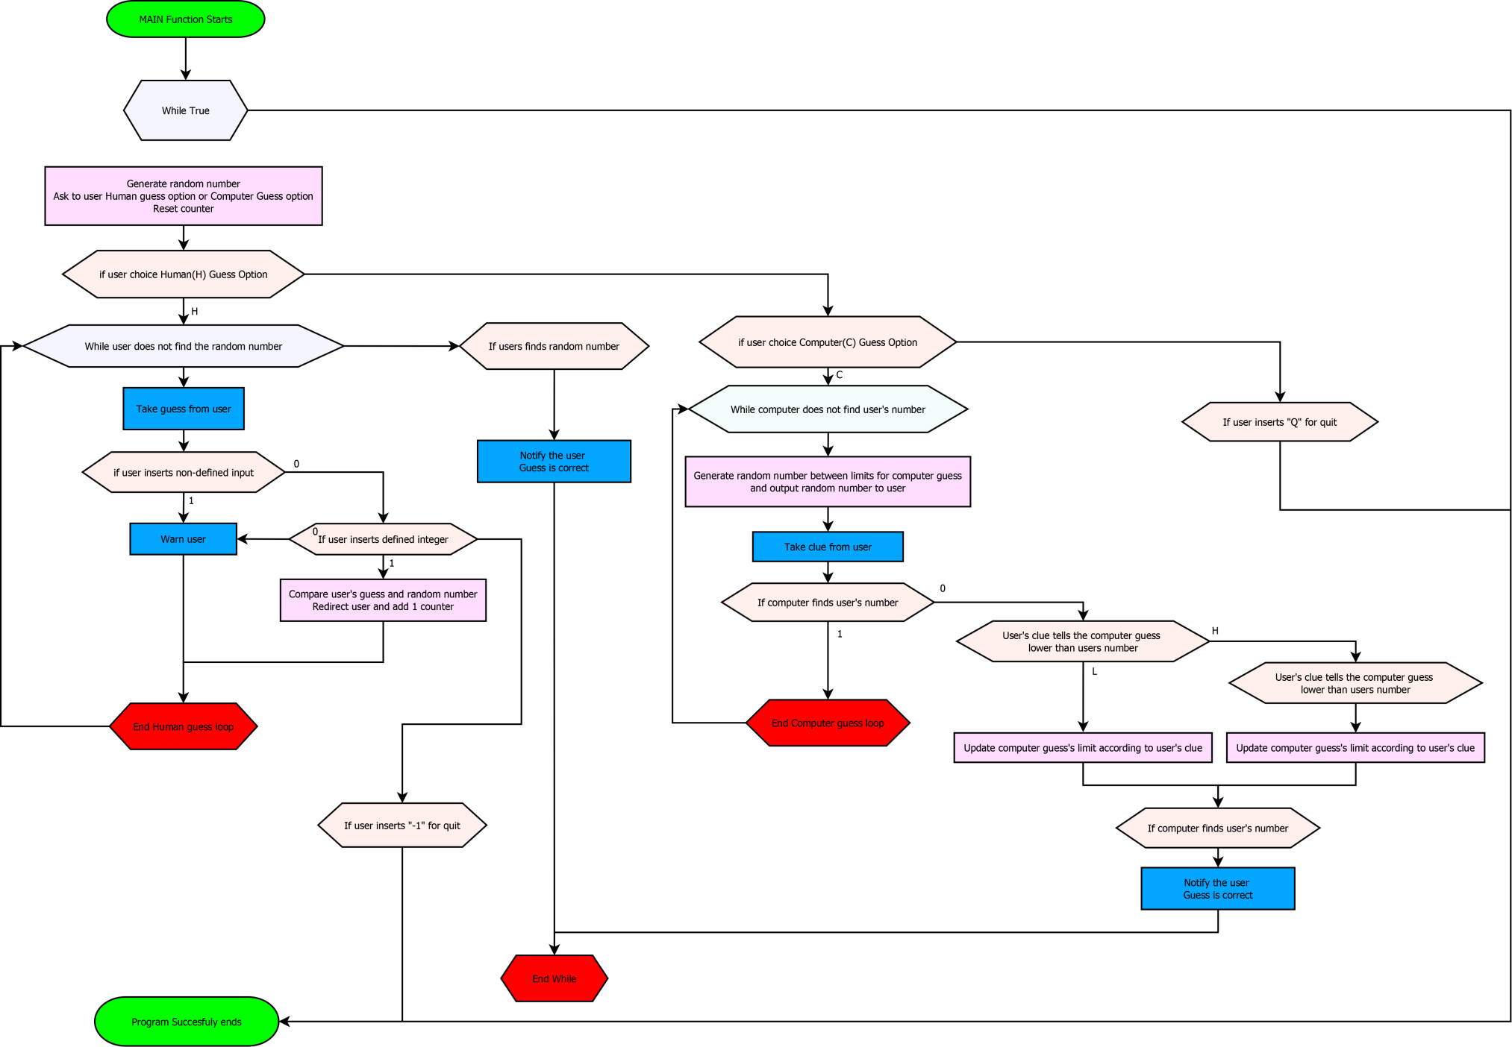

1. Conclusion

The program is compiled without any compiling warning. Necessary structures are applied on program. It is consistent and it runs without any runtime error. Program responds user’s requirements. The project reached aimed target.